Application Outline for Watershed Restoration Projects

Section I – BACKGROUND INFORMATION

- Introduction
In the upper Big Hole Basin, the TMDL and a Federal program known as the Candidate Conservation Agreements with Assurances program (CCAA) are being developed and implemented concurrently. The CCAA is dedicated to restoring the last native self-sustaining population of imperiled fluvial Arctic grayling in the lower United States (refer to Section B for further description). Many of the TMDL water quality goals (riparian zone improvement, summer temperature reductions, nutrient reductions, and pool frequency/channel function) are highly congruent with the CCAA goals and conservation measures. Under the CCAA, priority projects have been identified in the upper Big Hole, some of which overlap with this project.

This project addresses Montana’s Nonpoint Source Management Plan’s five-year resource-specific goals including:

- Develop a Watershed Restoration Plan that addresses combined water quality and grayling restoration targets and restoration plans for both programs;
- Implement restoration projects identified in water Quality Plans/TMDLs and, where possible, that overlap with Big Hole CCAA;
- Monitor restoration activities for effectiveness and pollutant load reductions;
- Facilitate and coordinate educational forums and strategic decision-making by the Drought Advisory Panel around drought, floodplain development, and water quality restoration actions in the Big Hole watershed;
- Assure adequate and successful oversight, coordination, reporting, and completion of all project tasks.

B. Statement of Need and Intent
This project takes place in the Big Hole Watershed, HUC 10020004, in Beaverhead, Butte-Silverbow, Anaconda-Deerlodge, and Madison Counties in southwest Montana. The projects outlined in this proposal will take place on the following impaired water bodies (1996, 2004, and 2006 303[d] lists): i)Mainstem Big Hole River, listed for physical substrate, habitat alteration, and temperature, and ii) Governor Creek, listed for sediment, physical substrate habitat alteration and alteration of streamside vegetation. This project will meet several EPA objectives including improving water bodies by removing impairment causes and improving water quality conditions on a watershed basis.

According to the Upper Big Hole TMDL restoration framework priorities:
“The most important restoration approach for reducing sediment, thermal and nutrient loading in the upper Big Hole Valley is streamside riparian restoration and long term riparian zone management. Stream channel restoration may be necessary in areas that have lost channel integrity due to long term riparian vegetation impacts. Other sediment restoration actions would include unpaved road erosion control near streams…Most of the sediment TMDLs identify eroding banks as the largest human influenced sediment source. Riparian vegetation restoration will address this source along with channel restoration that may be necessary in heavily impacted stream reaches where channel stability has been compromised by long term riparian vegetation impacts”.

The Big Hole Watershed supports a population of nearly 2,000 people. Most make their living from agriculture, primarily irrigated hay production and livestock. The Big Hole River is also a world class blue-ribbon trout fishery that is visited by thousands of fishermen each year which provides an enormous economic benefit to the local community. Low stream flows affect all those interests, sometimes resulting in tension and conflict. Water shortages in the watershed manifest as low summer streamflows in the mainstem of the Big Hole River. Causes of water shortages include gradual climate shifts to drier winters and warmer spring temperatures, persistent short-term drought conditions, and aging, inefficient irrigation infrastructure. Low streamflows combined with loss of riparian habitat due to streambank modifications create thermal and sediment/siltation impairments. These are documented factors in declines in fish populations. The BHWC proposes to address these TMDL water quality issues while also addressing high priority goals for numerous other partners and initiatives, described below.

The BHWC is an exemplary model of the watershed approach for effective problem solving around natural resource concerns. The BHWC formed in 1995 to resolve conflicts around low stream flow. The BHWC is a model of successful collaborative consensus decision making and results orientation. Listed below are some of the accomplishments of the group:
- Drought Management Plan – In 1999, the BHWC, along with Montana Fish, Wildlife and Parks (FWP), implemented the first drought management plan (DMP) in Montana, a plan that served a model for drought plans subsequently adopted throughout the state. The purpose of the DMP is to mitigate the effects of low stream flows and lethal water temperatures for fisheries through a voluntary effort among agriculture, municipalities, business, conservation groups, anglers, and affected government agencies. The DMP has been successful in improving streamflows compared to years prior to the plan.
- Research and Studies – The BHWC commissioned or sponsored numerous scientific studies with in the basin including:
- Storage Study – The goal of this study was to identify potential water storage locations that might be suitable for contributing to in-stream flows in the critical upper reach of the Big Hole River.
- Water Management Study – This study examined water management alternatives that could contribute additional sources of water for the purposes of late-season instream flow (for example: irrigation management, irrigating for hay versus pasture, stockwater wells, restoring wetlands, reintroducing beaver to tributary headwaters).
- Vegetation Community-Water Budget Study – This study examined the relationship between historic changes in upland vegetation and flows in the upper Big Hole River basin and predicts the ways in which manipulation of coniferous forests in the headwaters would affect instream flow.
- Ground Water–Surface Water Study–Under the auspices of the Montana Bureau of Mines and Geology, this study examines the relationship of irrigation practices in the upper Big Hole to instream flow.
- Land-Use Planning – The BHWC facilitated a three year process that resulted in adoption of the first watershed-wide development setback in the state. The setback is citizen supported and was adopted into the growth plans of all four counties that intersect the river. As part of the planning process, the BHWC was successful in securing a 100–year floodplain map acceptable to FEMA and used by planners, sanitarians, and floodplain managers throughout the watershed.
- Riparian Restoration and Irrigation Infrastructure Improvement Projects – Since 2004, the BHWC has partnered in or provided sole project oversight for 21 projects. The BHWC raised nearly $1-million dollars and leveraged nearly $5-million to accomplish those projects through state, federal, private, and foundation sources.

The BHWC proposes to address TMDL water quality issues while also addressing high priority goals for initiatives for partners listed below:

Candidate Conservation Agreement with Assurances (CCAA) Program: In the upper Big Hole, the BHWC is a partner in an ambitious conservation and restoration initiative known as the Candidate Conservation Agreement with Assurances or CCAA. The Big Hole CCAA is the largest of its kind ever attempted in the US. Bringing together local, state, and federal agencies, private landowners, non-profit organizations and many other parties, the CCAA will develop restoration projects targeting the last remaining population of fluvial Arctic grayling in the lower 48 states. FWP and USFWS determined that the most immediate human-influenced threats to fluvial Arctic grayling in the Big Hole River are habitat loss, degradation, and fragmentation. The CCAA proposes to remediate those threats by addressing the following four issues: reduced streamflows; degraded and non-functioning riparian habitats; barriers to fish migration; and entrainment in ditches. The agencies “have developed a phased implementation schedule to provide immediate and long-term benefits to grayling, facilitate maximum landowner participation, and enable development of meaningful site-specific plans that are tailored to (each) property,” including a monitoring plan.

Montana Comprehensive Fish & Wildlife Conservation Strategy (Montana Conservation Strategy): The Big Hole is considered a top priority under several of the four components listed under the Montana Conservation Strategy). Under the Focus Areas component, conservation actions proposed for the Big Hole include “restore stream channels, streambanks and riparian areas to a condition that simulates their natural form and function”; “increased installation of stockwater wells”; “support government and private conservation activities that encourage and support sustainable land management practices in riparian areas”; “implement various water conservation or flow management practices that restore essential habitats, simulate the natural hydrograph and also protect instream flows”. Under the Community Types component, as a mountain stream, the Big Hole is a Tier I aquatic community priority, with Arctic grayling identified as an Associated Species of Greatest Conservation Need. Conservation actions proposed for the Big Hole under these components include “restore stream channels, streambanks and riparian areas to a condition that simulates their natural form and function.” Under the Species component, Arctic grayling is a Tier I fish species identified, with proposed conservation strategies including “riparian rehabilitation projects to identified degraded habitats on the Big Hole River”.

Big Hole Watershed Committee Prioritization With the adoption of the CCAA program on the upper Big Hole, the Big Hole Watershed Committee facilitated a series of meetings in order to identify concerns and priorities for lower Big Hole River stakeholders who are not in the CCAA-reach of the Big Hole. The meeting included a broad spectrum of stakeholders including Big Hole River residents, conservationists, recreationists, local government representatives, conservation district supervisors, and representatives from the outfitter/guide community. In addition, numerous agency representatives participated, including DNRC, MFWP, USFWS, BLM, NRCS, and DEQ. The meetings resulted in a list of 18 concerns. The BHWC is focusing on the first four concerns: inappropriate floodplain development; providing for long-term improvement of the fishery; gaining a better understanding of the relationship between river flows and how river water is being used; and providing opportunities to improve irrigation infrastructure and water management.

C. Collaborative Effort
The BHWC is a non-profit 501(c)(3) – (Tax ID #11-3737644). Founded in 1995, the BHWC is a multi-stakeholder, consensus organization composed of 22 governing members representing diverse interests. Half of our members are ranchers. Other members represent sportsmen, conservationists (including Big Hole River Foundation, Trout Unlimited, Skyline Sportsmen, and The Nature Conservancy), outfitters and guides, recreationists, utilities, and local government. In addition, local, state and federal agency participants serve as technical advisors to the Committee (including USFWS, NRCS, USFS, BLM, DEQ, MFWP, and DNRC). The BHWC holds monthly meetings that are advertised and open to anyone interested in Big Hole Watershed issues. Information about the BHWC and many of the on-going projects and partnerships can be found at www.bhwc.org. Attached are letters of support from MFWP, DNRC, USFWS, and Beaverhead County Commissioners.

D. Project Planning and Management
All projects undertaken by the Big Hole Watershed Committee involve technical advisory panels consisting of private stakeholders including local governments, ranchers, recreational landowners, anglers, outfitters and guides, conservation organizations, and sportsmen’s’ groups. In addition, all relevant state and federal agencies are represented on these technical advisory panels including USFWS, NRCS, DNRC, MFWP, DEQ, BLM, and USFS. Planning includes stakeholder and agency involvement in project prioritization; development of work plans and timelines, determination of most qualified vendors lists, monitoring plans and methodologies, and designation of responsible parties. Quarterly meetings of technical advisory panels assure planning and management remains on target.
Contractors will prepare Quality Assurance Project Plan (QAPP) and Sampling and Analysis Plan (SAP) as appropriate to project task. QAPP and SAP will be completed in accordance with DEQ requirements and will be approved prior to initiation of project or effort. Deliverables will include final reports in both hardcopy and electronic format.

SECTION II – PROJECT COMPONENTS

A. Reporting Requirements
Reporting and invoicing will be made on monthly or quarterly basis by the BHWC and will include receipts, match reporting, copies of sign-in sheets, itinerary/agendas, minutes/interim reports, photographs, and summary status reports as appropriate to activity. A comprehensive “stand alone” final report will be provided in digital and electronic format for inclusion in DEQ’s Grant Reporting and Tracking System.

B. Education and Outreach Component
The BHWC will implement watershed-wide education and outreach campaigns targeting growth and development issues in floodplains and wetlands, drought management, riparian and wetland buffer protection, and riparian enhancement projects that address TMDL water quality plans. Components of the education and outreach campaigns will include press releases, quarterly newsletters, website updates, community forums, and watershed tours.

C. Watershed Activity Component – Tier II
This project will develop a Watershed Restoration Plan (WRP) that contains EPA’s nine minimum elements. Some of these elements have already been developed. Other elements will be developed through the WRP. Development and completion of the WRP will be in collaboration with a partnership of state, federal, and private partners involved in upper Big Hole Basin activities including: BHWC, Montana Trout Unlimited (TU), Big Hole River Foundation (BHRF), The Nature Conservancy (TNC), MFWP, DEQ, USFWS, NRCS, Arctic Grayling Recovery Program (AGRP), DNRC, local stakeholders, and others. Planning includes stakeholder and agency involvement in project prioritization; development of work plans and timelines, determination of most qualified vendors lists, monitoring plans and methodologies, and designation of responsible parties. Quarterly meetings of technical advisory panels assure planning and management remains on target.

One high priority project on Governor Creek in the upper Big Hole will be supported by this application. This tributary of the Big Hole River is listed in the 303(d) list. The project will address a significant cause of impairment to water quality on this stream. USFWS and Beaverhead County will be responsible for contracting, permitting, and project management. MFWP, USFWS, DNRC, and NRCS have developed a QAPP covering water sampling, streambank and stream channel morphology, and riparian habitat monitoring activities. With approval by DEQ, this monitoring plan will be adhered to and undertaken as an in-kind benefit to this project.

D. Operation and Maintenance Component
Operations and maintenance will be under the auspices of county government or state and federal agencies. For those between the BHWC and private landowners, an MOU will outline landowner responsibility with respect to project and infrastructure maintenance. Any MOU will be submitted to DEQ for approval prior to signature. Participating landowners have agreed to site-specific plans that include an annual and/or five-year monitoring schedule for duration of twenty years.

E. Monitoring Component
The CCAA monitoring strategy will be used for any project implemented in the upper Big Hole. That strategy was developed among MFWP, USFWS, DNRC, and NRCS. Monitoring will be conducted annually and on a five-year schedule using county, state, and federal agency staff. Goal of monitoring component will be to evaluate the effectiveness of on-the-ground projects and establish a framework for future restoration project implementation and monitoring programs.

SECTION III – SCOPE OF WORK

GOAL 1: DEVELOP A WATERSHED RESTORATION PLAN.

OBJECTIVE 1: A Watershed Restoration Plan (WRP) will be developed consistent with requirements for EPA’s nine minimum elements.

TASK 1: Collaborate with existing Big Hole Partnership to consolidate multiple initiative goals and priorities into a single document meeting EPA requirements for WRP’s
- Identification of causes of impairment (Achieved)
- An estimate of the load reductions expected from management measures (Needed)
- A description of the nonpoint source management measures that will need to be implemented to achieve load reductions (Achieved).
- Estimate of the amounts of technical and financial assistance needed, associated costs, and/or the sources and authorities that will be relied upon to implement this plan (Needed).
- An information and education component used to enhance public understanding of the project and encourage their early and continued participation in selecting, designing, and implementing the nonpoint source management measures that will be implemented (Achieved).
- Schedule for implementing the nonpoint source management measures identified in this plan that is reasonably expeditious (Needed).
- A description of interim measurable milestones for determining whether nonpoint source management measures or other control actions are being implemented (Needed).
- A set of criteria that can be used to determine whether loading reductions are being achieved over time and substantial progress is being made toward attaining water quality standards (Partially Achieved)
- A monitoring component to evaluate the effectiveness of the implementation efforts over time, measured against the criteria established (Partially Achieved)

DESCRIPTION: Services of a consultant will be secured to complete this task. With support of BHWC, consultant will organize and facilitate meetings of existing upper Big Hole Partnership. Through these meetings and in private consultation with separate entities, consultant will define scope of watershed planning effort, identify, gather and consolidate existing data and targets, identify data gaps, and provide a project prioritization matrix that identifies pollutant reduction potential. Of the

COSTS: 319 Funds: $20,000 Matching Funds: $8,000

RESPONSIBLE PARTY(s): Completion of the WRP will be in conjunction with a consultant and a partnership of state, federal, and private partners involved in upper Big Hole Basin activities including: BHWC, TU, BHRF, TNC, DEQ, MFWP, USFWS, NRCS, AGRP, DNRC, USFS, BLM, local stakeholders, and others. BHWC will be responsible for assuring completion of tasks, coordinating partners, and grant management including invoicing, match-tracking, and reporting.

TIMELINE: November 2009 – March 2010

GOAL 2: PROJECT MONITORING

OBJECTIVE 2: Data gathering related to monitoring needs.

TASK 2: Pre-project baseline data gathering and post-project monitoring will be conducted with the goal of evaluating project success related to water quality, stream morphology, riparian vegetation and biological health.

DESCRIPTION: Monitoring and evaluation will allow adaptive management of future restoration and enhancement projects throughout the Big Hole River valley. In addition to monitoring of the Governor Creek project described below (Goal 3), monitoring will include evaluation of recently completed riparian restoration projects along approximately 20 miles of the Big Hole River between Jackson and Wisdom, MT. Through monitoring, necessary modifications can be applied to restoration projects yet to be completed. Further, this adaptive management approach can be applied to grazing or water management systems. A Sample Analysis Plan and potentially a Quality Assurance Project Plan will be approved by MT DEQ. The CCAA monitoring strategy developed by MFWP, USFWS, DNRC, DEQ and NRCS will be used. Monitoring will be conducted annually and on a five-year schedule using county, state, and federal agency staff, or agency-supervised technicians. MFWP, USFWS, DNRC, and NRCS have developed a QAPP covering water sampling, streambank and stream channel morphology, benthic macroinvertebrate, and riparian habitat monitoring activities. Specific parameters include abundance, distribution and age-class structure of salmonids; permanent cross sections for stream channel morphological change including width:depth ration and riffles/pools. Riparian assessments will be conducted the first year post-project and then every 5 years, following the NRCS riparian assessment protocol to determine long-term riparian recovery and habitat conditions. Permanent photo points will be established for all projects.

COSTS: 319 Funds: $ 30,000 Matching Funds: $20,000

RESPONSIBLE PARTY(s): MFWP, USFWS, NRCS, DNRC and agency-trained partners or technicians will conduct annual site specific monitoring. With oversight of DEQ and other agency partners, BHRF will take the lead on benthic macroinvertebrate monitoring. BHWC will be responsible for assuring completion of tasks, coordinating partners, and grant management including invoicing, match-tracking, and reporting.

TIMELINE: July 2009 - October 2011

OUTPUTS (DELIVERABLES):
Pre- and post-monitoring data will assess effectiveness of project in terms of sediment load, streambank stability, riparian vegetation type and density, and stream channel morphology. A Sample Analysis Plan and potentially a Quality Assurance Project Plan for sediment load reduction effectiveness will be submitted to DEQ for approval prior to project implementation. All data collected will be entered into STORET by contractor.

GOAL 3: GOVERNOR CREEK CULVERT REPLACEMENT PROJECT

OBJECTIVE 3: Improve channel integrity, water flows and fish passage in Governor Creek by replacing deteriorated road culverts with a flood plain –spanning bridge to meet water quality and fish passage concerns and allow the stream to function naturally throughout this road crossing area.

TASK 3: Working with USFWS and Beaverhead County Commissioners, complete funding and construction of the Governor Creek Culvert Replacement project. This project outcome will be to simultaneously reduce a notable source of stream channel degradation, road sediment, and habitat alteration and to remove a major fish barrier.

DESCRIPTION: “Governor Creek, a tributary of the Big Hole River, lies in the southern end of the upper Big Hole River planning area. Its headwaters originate in the Beaverhead Mountains and flow northward to its confluence with the Big Hole River near Jackson, Montana. About 2 miles of the length of Governor Creek flow through mountainous topography on USFS holdings. The remaining 20 miles occupy a rangeland environment on private land.

Probable causes of impairment in Governor Creek include sediment and related pollution such as dewatering, fish habitat degradation, and other habitat alterations” (DEQ, 2007, draft TMDL, unpublished data). Comparison of conditions in and along Governor Creek to numeric targets and supplemental indicators provides support for listing for sediment. The area of eroding banks exceeded targets substantially on two of the three assessed reaches. Moreover, measures of riparian cover classes indicated reaches had reduced shrubs and elevated bare ground, conditions that reduce filtering capacity and decrease bank protection. None of the three assessed reaches met the target for width-to-depth depth ratio indicating an overly wide channel with reduced sediment transport capabilities” (DEQ, 2007, draft TMDL, unpublished data).

The Governor Creek culvert has been identified as a barrier to fish migration and was given a high priority by under the CCAA. The deteriorated culverts present a physical barrier to upstream fish passage, as well as a velocity barrier at high flows. USFWS and MFWP have committed to contributing more than 50% of project cost.

This project has received widespread support from a diverse partnership including private landowners and the county. A preliminary engineer’s budget for the project is $425,000 (including design cost). The preliminary was paid for by Beaverhead County and is completed.

Monitoring Plan: MFWP, USFWS, DNRC, and NRCS have developed a QAPP covering water sampling, streambank and stream channel morphology, and riparian habitat monitoring activities. This monitoring plan will be adhered to and undertaken as an in-kind benefit to this project. Responsibilities will be as follows: MFWP and/or USFWS biologists will conduct annual site specific monitoring of the abundance, distribution and age-class structure of salmonids; monitoring of permanent cross sections for stream channel morphological changes, width:depth ration and riffles/pools. Riparian assessments will be conducted the first year post-project and then every 5 years, following the NRCS riparian assessment protocol to determine long-term riparian recovery and habitat conditions. Permanent photo points will be established.

COSTS: 319 Funds: $50,000 Matching Funds: $375,000

RESPONSIBLE PARTY(s): Beaverhead County and USFWS will oversee completion of the project. USFWP, MFWP, NRCS, and DNRC will conduct the monitoring program. BHWC will provide project management, communication, outreach and education, reporting to DEQ, and administer 319 funding.

TIMELINE: September 2010 through December 2011

OUTPUTS (DELIVERABLES): Culverts at county road crossing Governor Creek will be replaced by pre-cast concrete bridge. This will result in improved stream channel integrity, cooler stream flows, reductions in bank sediments, and fish passage. This well-constructed new bridge will be certified by a qualified engineering firm. Sediment data will be collected and entered into the DEQ database system.

GOAL 4: PROJECT MANAGEMENT AND STAKEHOLDER COORDINATION

OBJECTIVE 4: Organize and facilitate partner and stakeholder meetings and necessary project site visits.

TASK 4: Facilitate communication and coordination among partners and stakeholders to assure swift and seamless completion of WRP, monitoring program, education and outreach program, and on-the-ground projects in the upper Big Hole TMDL area.

DESCRIPTION: BHWC will facilitate communication and coordination among Partners in order to reduce redundancy in effort, reduce the number of meetings, increase capacity of all Partners, and assure project tasks are being met. Monthly community meetings and public forums will be organized and facilitated. The purpose of these public gatherings is to encourage citizen participation in watershed discussions and activities, determine community goals and priorities with regard to watershed concerns, offer assistance in implementing community goals, promote effective communication, and coordinate interaction among community-based groups and agencies.

COSTS: 319 Funds: $30,000 Matching Funds: $29,000

RESPONSIBLE PARTY(s): BHWC will be responsible for all aspects of this task.

TIMELINE: July 2009 through July 2011

OUTPUTS (DELIVERABLES): At least one monthly community meeting and four quarterly partner meetings will be organized and facilitated each month within the basin. These meetings will address some aspect of species recovery, growth and development issues, drought management, riparian and wetland buffer protection, and riparian/water quality enhancement projects. Results of the meetings will include community-supported growth management plans, implementation of at least one priority water management or riparian enhancement project per year. BHWC will schedule, manage and assure tasks described in this project are completed in timely manner and on-budget. BHWC will further ensure that all activities and 319 requirements are met in a timely manner and that all products are properly completed and delivered. DEQ will be provided with monthly or quarterly reports that will include copies of meeting minutes, attendance lists, and photographs as appropriate. Monthly, quarterly and final reports will be supplied both as hard and electronic documents Final report will be in a professional “stand alone” format and will incorporate WRP, monitoring methods descriptions and data, participation and match statistics, interim reports, minutes, memoranda, photographs of projects and activities, etc.

GOAL 5: EDUCATION AND OUTREACH

OBJECTIVE 5: BHWC will encourage citizen participation in watershed activities, determine community goals and priorities, provide education and information, offer assistance in implementing community goals, promote effective communication, and coordinate interaction among community-based groups and agencies.

DESCRIPTION: BHWC will implement watershed- and region-wide education and outreach campaigns targeting species recovery, growth and development issues, drought management, riparian and wetland buffer protection, and riparian/water quality enhancement projects. Components of the education and outreach campaigns will be quarterly newsletters, website development, community forums, and watershed tours.

TASK 5: Prepare and distribute quarterly newsletters

COSTS: 319 Funds: $10,000 Matching Funds: $6,000

RESPONSIBLE PARTY(s): BHWC will be responsible for all aspects of this task.

TIMELINE: July 2009 through July 2011

OUTPUTS (DELIVERABLES): Quarterly newsletters will be provided via hardcopy or email to over 1,500 Big Hole stakeholders. A more informative and accessible website will be developed and will be updated on a weekly basis. No fewer than two annual news releases will be published in regional papers highlighting successes in issue areas.

TASK 6: Watershed Tours & Education Forums for Children and Adults

DESCRIPTION: Watershed tours will highlight past, present, and future watershed enhancement activities and provide valuable information about stewardship of the basin and its waters. A children’s watershed education program will be developed that will foster a sense of wonder and responsibility toward the waters of the Big Hole basin. Target audience will include stakeholders, children, nonprofit partners, local government partners, and state and federal agency partners.

COSTS: 319 Funds: $8,000 Matching Funds: $15,600

RESPONSIBLE PARTY(s): BHWC will be responsible for all organizational aspects of this task. BHWC will partner with Montana Watercourse, Montana Tech, Big Hole River Foundation, Montana Bureau of Mines & Geology, Clark Fork Watershed Education Forum, UM Western, Museum of Fine Arts Butte, and all local community schools within the watershed. Agency partners will include MFWP, DEQ, DNRC, NRCS, USFWS, and local governments including conservation districts and county commissions.

TIMELINE: July 2009 through July 2011

OUTPUTS (DELIVERABLES): A minimum of one annual watershed tour will be organized. A children’s watershed education program will be developed for the basin and at least one children’s program or event will be organized. Participation in tours and educational events will exceed one hundred participants (excluding presenters and organizers). DEQ will be provided with reports including tour goals, itineraries, press releases, maps, project descriptions, photographs, participant lists and evaluations

GOAL 6: ADMINISTRATION

OBJECTIVE 6: Assure tasks described in this project are completed in timely manner and on-budget.

DESCRIPTION: BHWC will administer billing and reporting to DEQ. BHWC will ensure that all 319 requirements are met in a timely manner and that all products are delivered. BHWC employee(s) will attend training conference that covers such topics as procurement, contract administration, contract management, accounting techniques, and match reporting.

TASK 7: Administration

COSTS: 319 Funds: $15,800 Matching Funds: $0

RESPONSIBLE PARTY(s): BHWC will be responsible for all aspects of this task.

TIMELINE: July 2009 through July 2011

OUTPUTS (DELIVERABLES): BHWC will assure timely payment of invoices and submission of billing and match statements; reporting, tracking of project budgets; provide oversight and achievement of all Tasks in this project including successful completion of DEQ accepted WRP, QAPP, SAP, and entry of monitoring data into STORET. Final report will be in a professional “stand alone” format and will incorporate WRP, monitoring methods descriptions and data, participation and match statistics, interim reports, minutes, memoranda, photographs of projects and activities, etc. Final reports will be supplied both as hard and electronic documents. BHWC will administer billing and reporting to DEQ. BHWC employee(s) will attend training conference that covers such topics as procurement, contract administration, contract management, accounting techniques, and match reporting.
SECTION IV – SUPPORTING DOCUMENTS

ATTACHMENT I – Project Milestone Table

ATTACHMENT II – Project Detail Budget Table

ATTACHMENT III – Project Map & Photos

ATTACHMENT IV – Letters of Support

ATTACHMENT I
MILESTONE TABLE

 |  | 2009/2010 |  |  |  |  |  |  |  | 2010/2011
Goal | Activity | 7/09-9/09 |  | 10/09-  12/09 |  | 1/10-  3/10 |  | 4/10-  6/10 |  | 7/19-  9/10 |  | 10/10-  12/10 |  |  |  |  |  | 1/11-  3/11 |  | 4/11-6/11 |  | 6/11- 8/11
1.1 | Develop Watershed Restoration Plan
2.1 | Project Monitoring
3.1 | Governor Creek Culvert Replacement Project
 | Monitoring Phase
4.1 | Project Management and Partner Coordination
5.1 | Education and Outreach – Quarterly newsletters
 | E and O – Watershed Tour/Children’s Program
6.1 | Administration

ATTACHMENT II
PROJECT DETAIL BUDGET TABLE

 | Project Cost | Secured  Non-Federal |  |  | Secured  Federal
GOAL | Total | Cash Match | In-Kind | Source | Cash Match | Source | 319 Request
1. Develop WRP | $28,000 |  | $8,000 | BH Partners |  |  | $20,000
2. Monitoring | $50,000 | $5,000 | $10,000 | BH Partners BHRF/FWP/TNC | $5,000 | USFWS | $30,000
3. Governor Creek Culvert Replacement | $425,000 | $305,000 | $20,000 | Bvhd County/  BHWC/FWP | $50,000 | USFWS | $50,000
4. Project Management | $59,000 | $6,000 | $23,000 | BHWC  BH Stakeholders |  |  | $30,000
5. E&O | $39,600 | $8,000 | $13,600 | BHWC  BH Partners  DNRC |  |  | $18,000
6. Administration | $14,800 |  |  |  |  |  | $14,800
TOTAL | $616,400 |  |  |  |  |  | $162,800

ATTACHMENT III
PROJECT MAP & PHOTOs

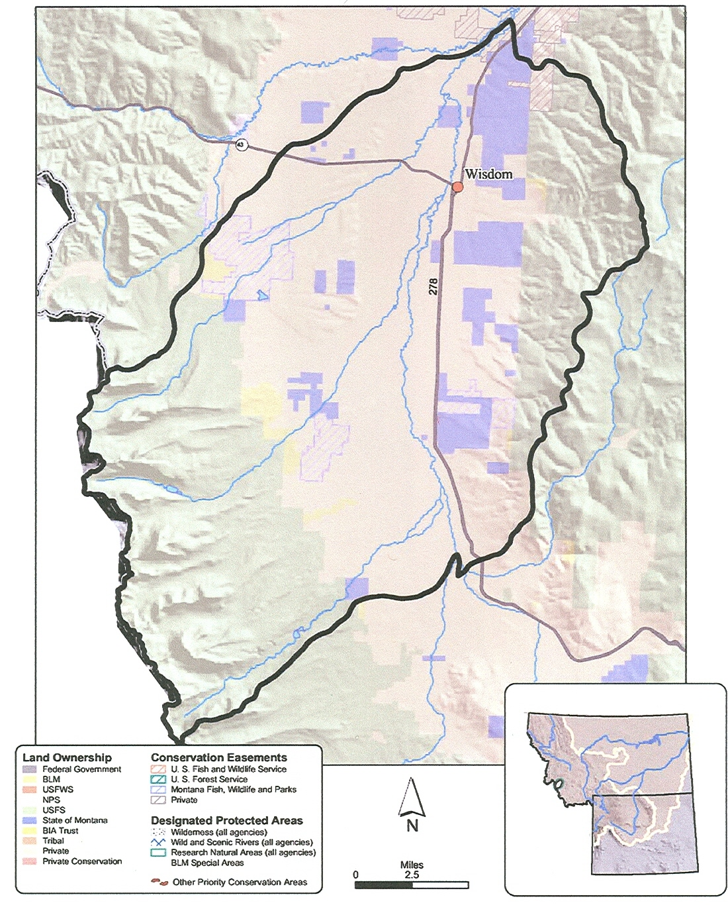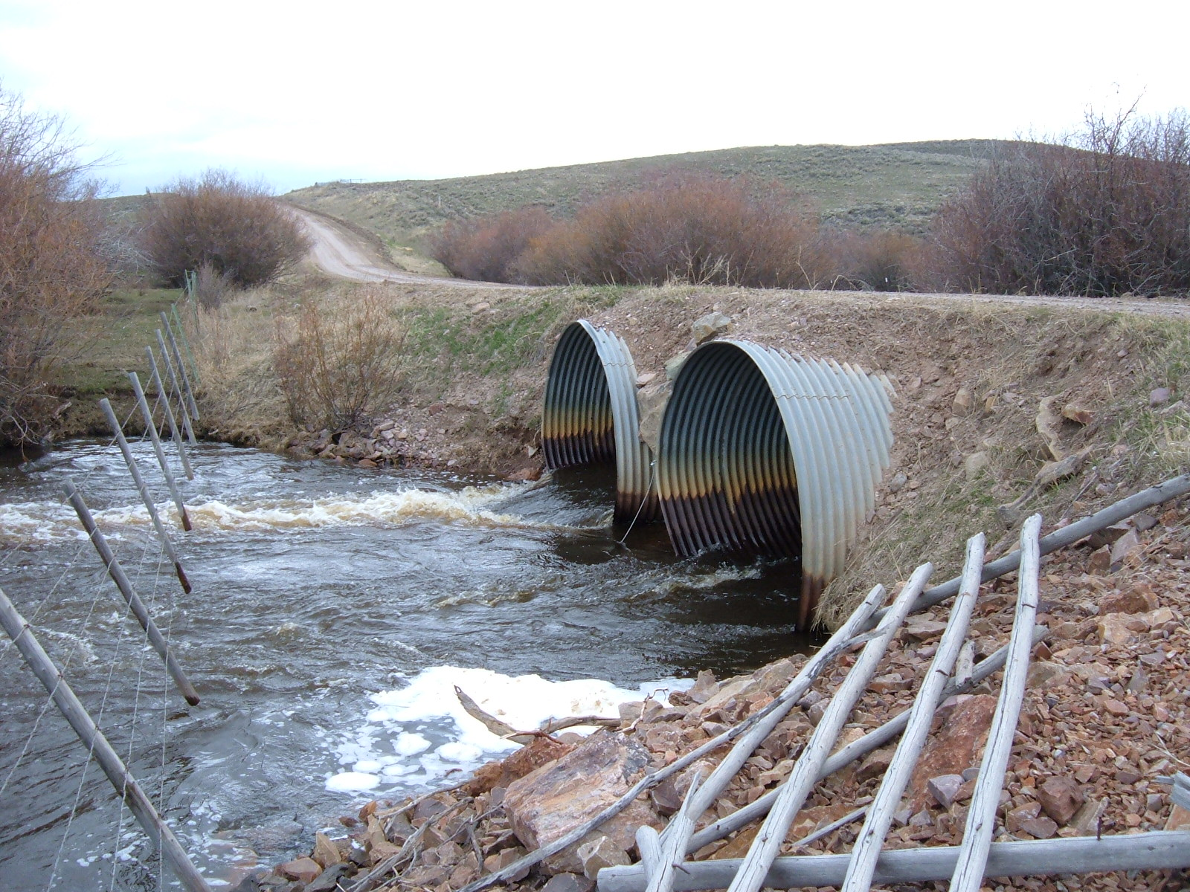
Upper Big Hole Watershed Governor Creek Culvert Replacement Project
Location: Skinner Meadows Road crossing (Section 35 T5S; R15W
ATTACHMENT V
LETTERS OF SUPPORT TABLE

Name | Title | Organization | Address
Tom Rice/Garth Haugland/Michael McGinley | Beaverhead County Commissioners | Beaverhead County | 2 South Pacific St. Suite #4  Dillon, MT 59725
Mike Roberts | Hydrologist | Montana Department of Natural Resources Conservation | 1424 9th Ave  PO Box 201601  Helena, MT 59620 - 1601
Jeff Everett | Wildlife Biologist | US Fish and Wildlife Service | USFWS  Dillon Ranger District  420 Barrett St  Dillon, MT 59725
Jim Olsen | Big Hole Fisheries Management Biologist | Montana Department of Fish, Wildlife and Parks | BUTTE Field Office  1820 Meadowlark Lane  Butte, MT 59701

