# Watershed Protection Program: 319 Project proposal Workshop Agenda

Wednesday, June 26, 2013

9:00 am - 12:00 p.m.

DEQ Metcalf Building, Room 111, 1520 East Sixth Avenue, Helena, MT

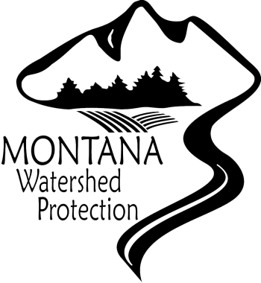Remote Access:

1. [http://img.gotomeeting.com/g2mimages/webinar/themes/basic/button_registerNow.gif](https://www2.gotomeeting.com/register/870763898)
2. Please join my meeting. <https://www2.gotomeeting.com/register/870763898>
3. Call in using your telephone.
   1. Call in number: 1-866-906-9888
   2. Passcode: 7508058

**9:00 a.m. Welcome and Introductions**

* Expectations
* Brief Summary of Proposed Project [if you have one]

**9:30 a.m. Overview of the FY2014 Call for 319 Project Proposals**

* Timeline
* Revised 319 Guidelines and Major Changes for FY2014
* Potential Projects
* Application Process
* Required Materials

**10:30 a.m. Demonstration of Application Forms**

**11:00 a.m. Q&A**

* Questions about process
* Questions about potential projects

**12:00 p.m. Adjourn**

**Table 1 - Schedule for Fiscal Year 2014 319 Program**

|  |  |
| --- | --- |
| **Date** | **Timeline** |
| 6/3/2013 | Issue call for project proposals |
| 6/26/2013 | 319 project proposal workshop, 9:00 am to 12:00 pm  *(For more information visit*  [*http://deq.mt.gov/wqinfo/nonpoint/319GrantInfo.mcpx*](http://deq.mt.gov/wqinfo/nonpoint/319GrantInfo.mcpx) *)* |
| 7/2/2013 | WRP Workshop, 9:00 am to 12:00 pm  *(For more information visit*  [*http://deq.mt.gov/wqinfo/nonpoint/319GrantInfo.mcpx*](http://deq.mt.gov/wqinfo/nonpoint/319GrantInfo.mcpx) *)* |
| ***Stage 1*** | |
| 7/26/2013 | 319 project proposals Due to DEQ |
| TBD-August | MWCC Review Meeting |
| 8/30/2013 | DEQ Comments Due to Project Sponsors |
| ***Stage 2*** | |
| 10/4/2013 | Final project proposals Due to DEQ |
| 10/9/2013 | Final project proposals posted to 319 Wiki site |
| 10/22/2013 | Evaluation by agency review panel |
| ***Stage 3*** | |
| 11/1/2013 | Letters for notice of intent to award mailed out |
| 12/31/2013 | Final Scopes of Work due |
| 1/31/2014 | Deadline for DEQ acceptance of WRPs |
| TBD | DEQ submits state of MT application for EPA review |
| TBD | DEQ sends out contracts to project sponsors |
| Before 6/30/2014 | Project sponsors return signed contracts |
| TBD | Funds available |